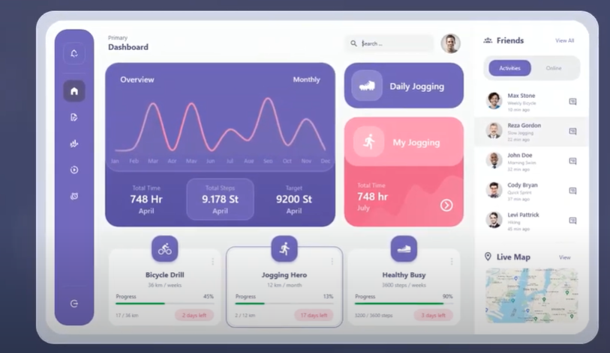

Sẽ tương ứng với thống kê doanh thu

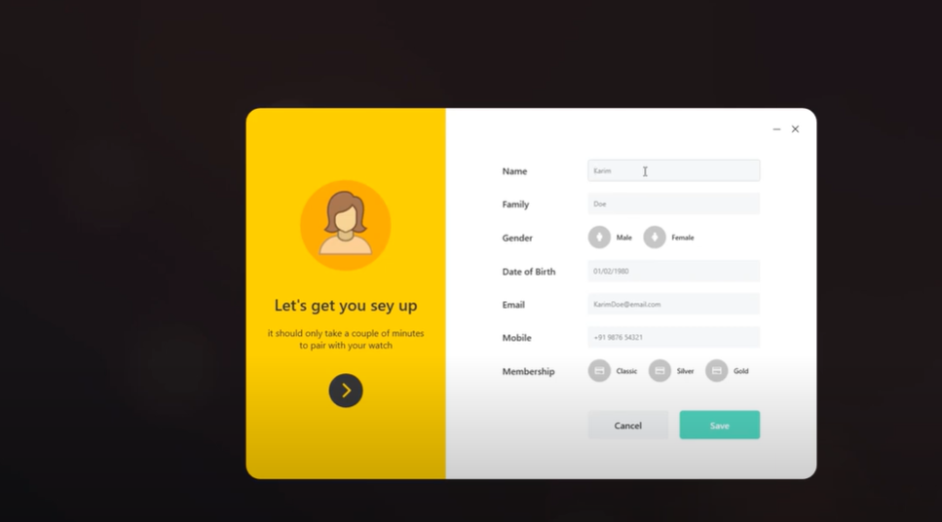

[**https://laptrinhvb.net/bai-viet/ebook-it/---Csharp----Chia-se-source-code-Form-Login-Animation/4816186ca5a1d7ff.html**](https://laptrinhvb.net/bai-viet/ebook-it/---Csharp----Chia-se-source-code-Form-Login-Animation/4816186ca5a1d7ff.html) **(animation - login )**

demo login

[**https://www.youtube.com/watch?v=c-UwqRZSk2g&t=153s&pp=2AGZAZACAQ%3D%3D**](https://www.youtube.com/watch?v=c-UwqRZSk2g&t=153s&pp=2AGZAZACAQ%3D%3D) **(sign up)**